Whatsapp sending app for CARE program v1

2020-03-09

FM

Pls let me know if you have any other questions through whatapps, wechat or email. Thank you.

1. Pls ensure you have the content file (csv), bulk sender(Care Wtaspp sender.exe) and the chrome drive (chromedriver.exe) in your PC.

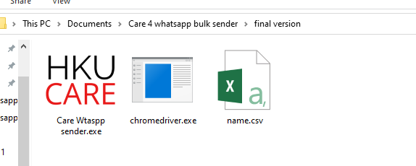

1. Prepare your content files in csv format. The data structure looks like the following pic:

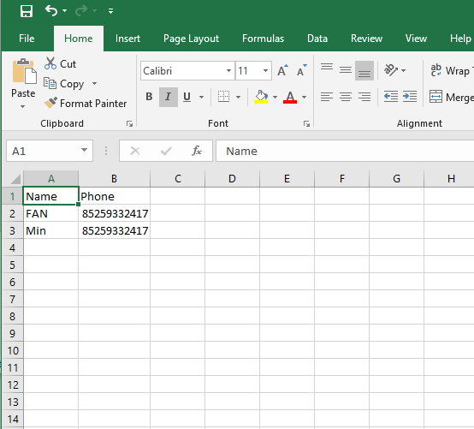

Pls remember to add the 852 in front of the telephone number.

Pls remember to save the file into csv UTF-8 format, otherwise it may cannot show the Chinese character correctly.

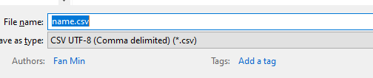

1. The current version of the sender does not need any coding. The UI looks like this:

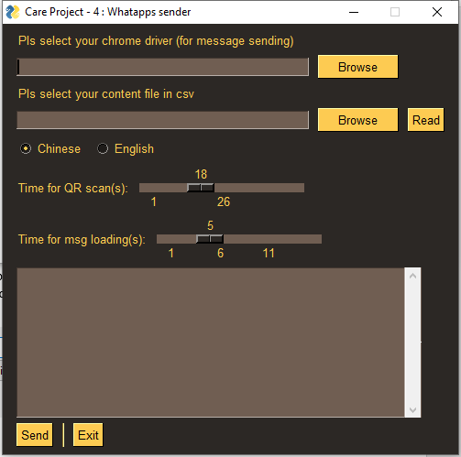

1. Select the chrome driver & Your content file and press read

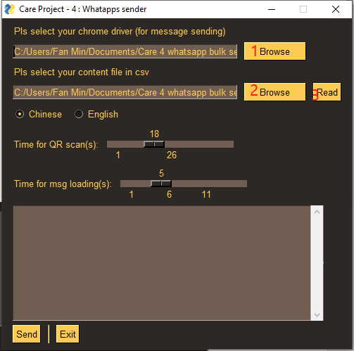

1. Some meta info will be shown below. Pls check if the number and name are correct.

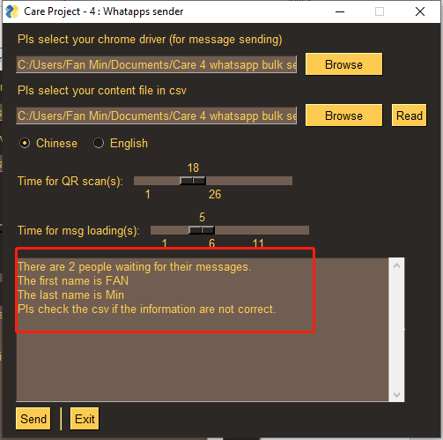

1. After double check, press Send. There will be a fake chrome coming out with whatsapp webpage.

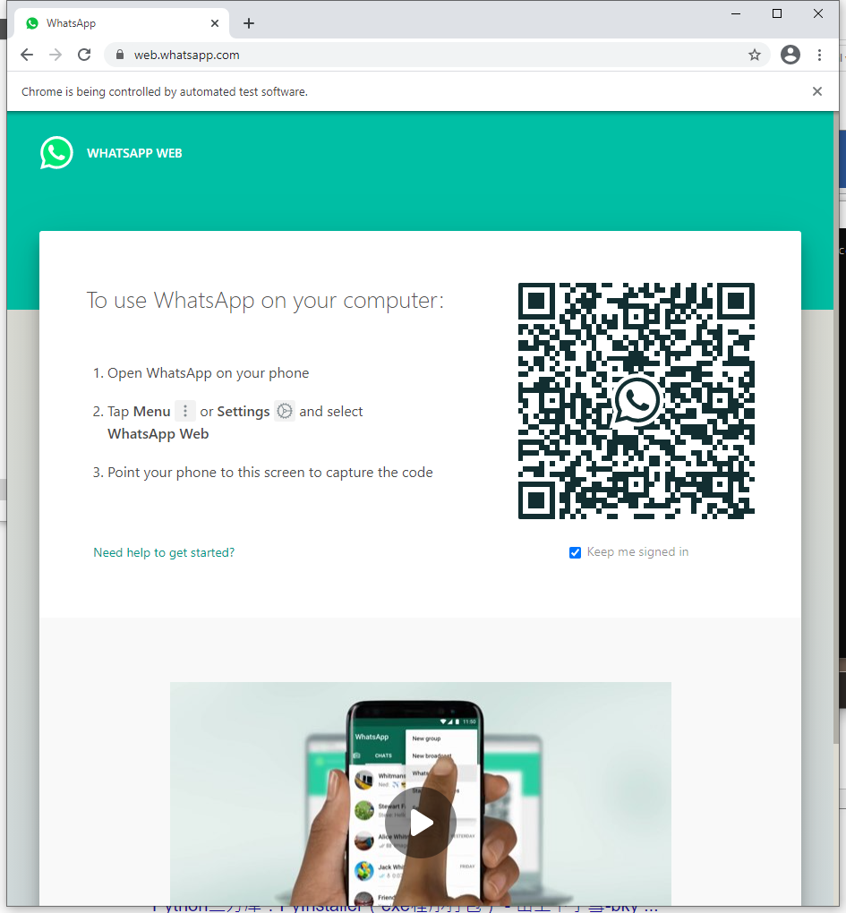

1. Scan with you whtaspp and just wait. The message will be automatedly sent to the people.

PS. 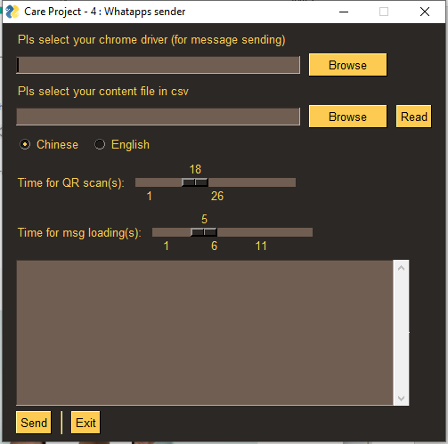

There are three additional functions in the sender. The Chinese and English button is fake since we only sending Chinese message to the participants. I can adjust it I we plan to use English msg.

The two-timing setting are quite important since the loading time may longer than expected with increasing number of chats in your Whatsapp account. So if you find the loading of your webpage is so long, pls increase the time in the program.